March 29, 2017

To whom it may concern,

Assumption College has had a relationship with DIB Audio Visual for several years. DIB’s positive reputation with teachers and contractors alike made the company an attractive recommendation. When the college was seeking a high-quality audio-visual provider to help with a newly refurbished school building it was natural to approach DIB.

The company’s quote for the college’s technology refurbishment was thorough and competitive and they were an easy choice for us. They helped us remove the old, outdated audio-visual equipment, helped us choose new products and installed these in a timely and efficient manner.

Our solutions consultant, James Ridd, was key to making the whole process quick and easy. He is extremely personable, approachable and professional. He is knowledgeable regarding products and installation practices giving us confidence that he had formulated the right solution for the classroom updates.

DIB were flexible in scheduling appointments, installations were successful, and any minor technological errors were quickly remedied by their service team.

Kind regards,

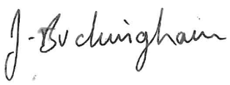

**Sam Camilleri Jennifer Buckingham**

**Audio Visual Coordinator Business Manager Operations**